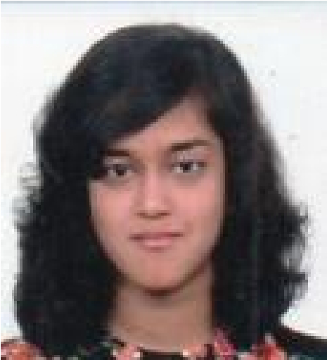 | Yvanka Maria Guia Rebelo  I have a passion for languages and love working with them.  I am fluent in English, French, German and Spanish.
  yvankaofficial@gmail.com    +91 7348846764    Flat N1103,  Mantri Webcity,  Near Southern Asian Bible College, Kothanur Post, Hennur Main Road, Bengaluru, Karnataka 560077 | WORK EXPERIENCE:  Jul 2024-to date: Currently working as a freelance language teacher with various institutions (Alliance Française Panjim and Bangalore, The Migration Company, Toronto French Academy, Strommen) and private clients  Aug 2023-Feb 2024: Worked at Ernst and Young as a French language specialist  Jan 2021- Jan 2024: Taught French, Spanish and German to students at ‘Besser Academy’  Oct 2022- May 2023: Worked as an Assistant English Professor in Collège Robert Beltz, Alsace (France) for 8 months.  2022: Worked as a freelance contributor with the English Academy ‘Synchrolearn’.  2021: Completed an internship with ESIGELEC, France, as a Content Writer.
COURSES AND TRAINING:
- French DALF Certification: C2
- German Goethe Zertifikat: B2
- Spanish DELE Certification: B1
- IELTS certified
SKILLS  - Fluent in English  (Mother  Tongue)  - Speak and Write French  (Level:C2)  - Speak and Write German  (Level: C1)  - Speak and Write Spanish (Level: B2)  INTERESTS  - Reading Classical Literature  - Writing  - Baking  - Gardening  - Travelling | EDUCATION:  - Bachelor of Business Administration:  St. Joseph’s College of Commerce, Bangalore: First Class Distinction  - Class 12: Indian School Certificate:  St. Joseph’s High School, Bangalore: Percentage: 86.75%  - Class 10: Indian Certificate of Secondary Education:  Clarence High School, Bangalore: Percentage: 92.75%
ACHIEVEMENTS AND RECOGNITION:
- 2024: Published a novella in the anthology ‘A Compendium of Crimes’
- 2024: Helped Launch Ajenor Times, A French language magazine with Alliance Française Panjim
- 2023: Published a novella in the anthology ‘Out of the Cauldron’ by Azala Press
- Published short stories in the following online magazines:
- Unverbalise
- Rewrite the Stars Review
- The Persimmon Review
- Published two detective fiction novels with Clarentian Publications:
- 2015: Rendezvous in Rwanda
- 2017: The Peloponnesian Puzzle
- Was on the Editorial Team of my College Newsletter at St. Joseph’s College of Commerce
- Was Sub Editor of the School Newsletter at Clarence High School
SOCIAL WORK EXPERIENCE:
2021-2023: Currently volunteering as a translator with the NGO Translators Without Borders. (English, French, German and Spanish).
2020: Completed 30 days internship at CBRF, Bangalore, as a Content Writer.

